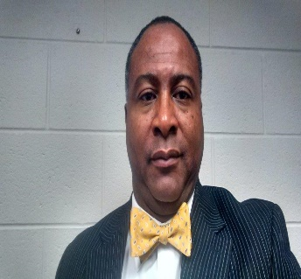
Dr. Maurice D. Carter, Ed.D.

The visionary and leader of the Crystal Cathedral Ministry is a native of Fluvanna, Virginia. He is a professed lifetime educator, orator and motivator for the last 40 years. He has a number of professional and educational achievements to his credit.
He received his Bachelor of Science degree in Education from Saint Paul’s College, Lawrenceville, Va. While attending St. Paul’s he was an academic all American while playing Football. He was a two year captain of the Football Team. He graduated Magna Cum Laude with high honors and distinction (3.98 Grade Point Average).
He was awarded a full scholarship to the Ohio State University in 1985. He earned a Master’s Degree in Public Administration in 1987 with high Honors (3.99 GPA). He also earned a Master’s in K-12 Supervision in 1996 from Longwood University with Honors (4.0 GPA). He attended and earned His Doctorate degree in Education Leadership at the University of Virginia in 2010.
Dr. Carter has served as a professor at Virginia Union University, Richmond, Va.; Southside Community College in Keysville, Va. and currently serves as a Graduate Professor in the School of Education and Human Services, teaching education leadership at Longwood University in Farmville, Virginia.
From 1993-1995 He assisted in developing the Day Treatment Program for the Elk Hill School for Boys in Goochland, Virginia. He also served as the Executive Director for the Center for Black Enterprise in the City of Richmond, Virginia from 1989-1992.
He has been a high school football Coach, Head basketball and Head track Coach, a Dean of Students, and an Assistant Principal and became the youngest Principal in the History of Fluvanna High School at 26 years old. He served as Assistant Superintendent for ten years. He also served as Superintendent for Fluvanna County Public Schools.
Upon leaving Fluvanna Schools in 2011, Pastor Carter and several friends created the Community Christian Academy (K-6 Christian School) on Rio Road in Charlottesville, Virginia.
Pastor is currently a senior partner along with Pastor Butch Well and Pastor Rickey White of a corporation called “N2Fruition” that deal with intellectual properties.
In 1993, Pastor and his wife, Deborah established the Crystal Cathedral Ministry in Farmville, Virginia. The ministry currently owns a $13.8 million dollar, 60,000 square foot facility canvassing 4 city blocks in the heart of Dillwyn, Va.
He has planted ministries in Charlottesville, Farmville, Waynesboro, Hopewell, and Louisa Virginia. He has served as the Chief of Staff for the Virginia Western Diocese of the Churches of Our Lord Jesus Christ of the Apostolic Faith for 15 years. He currently is the Presiding Bishop of that Diocese which consist of 17 churches located throughout the Commonwealth of Virginia.
Dr. Carter has coauthored a book on juvenile gangs; he has authored a self-help book for aspiring young ministers and is currently writing a book entitled: “He leads me beside the still Waters”.
He and his wife are happily married and have been together for 37 years. They have two biological children. Joshua is an Elementary Education teacher in Lynchburg, Virginia and Victoria is currently a senior attending Virginia State University majoring in Child Psychology.
Pastor is revered locally and nationally as a dynamic man of vision, leadership integrity and compassion.

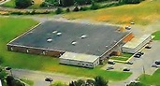
Aerial View of the Crystal Cathedral Ministry
16764 Oak Street, Dillwyn, Virginia 23936

Website: www.crystalministry.org
Church Number: (434) 983-8933
Dr. Carter’s Cell: (434) 996-5861
Home Address: 995 Shiloh Church Road
Palmyra, Virginia 22963
Dr. Carter’s Email: flucoman@aol.com
Church Mail Address: P.O. Box 53
Dillwyn, Virginia 23936
Church Email Address: Crystalministry@aol.com

